**Exercise 1 Design Patterns**

**1.2 and 1.3 class/sequence diagrams of the patterns used.**

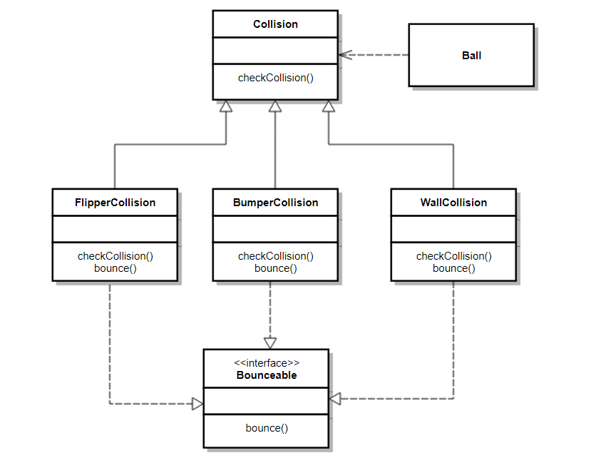

**Class diagram: Strategy**

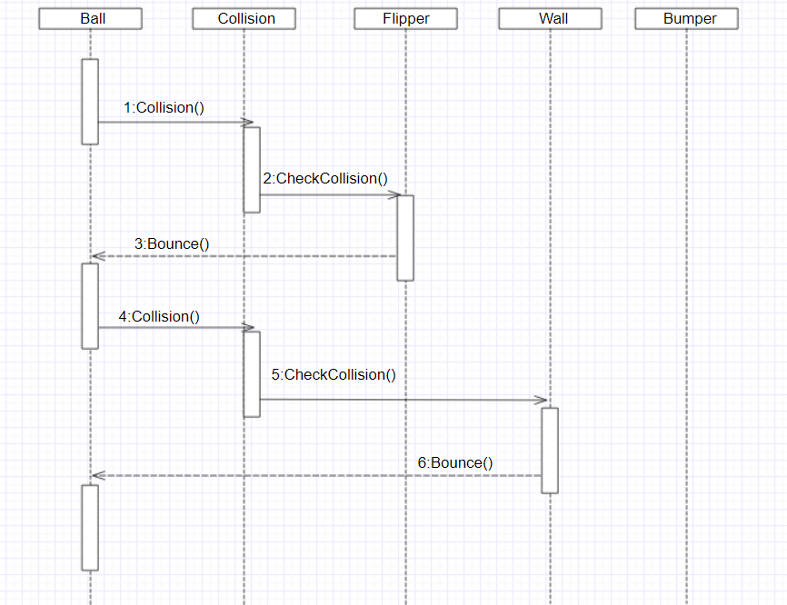

**Sequence diagram: Strategy**

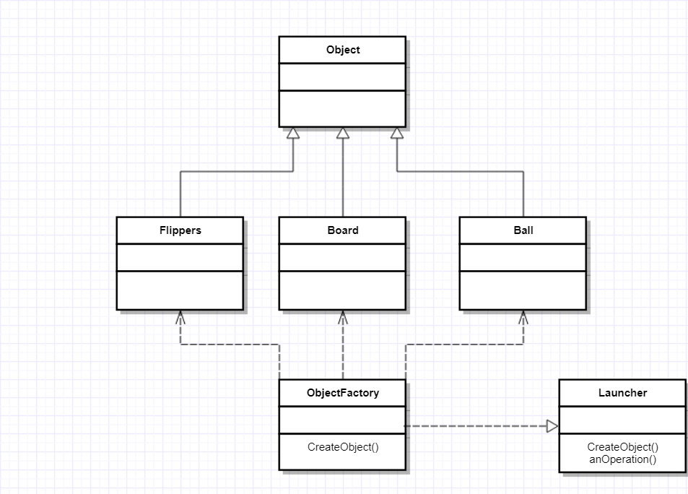

**Class diagram: Factory**

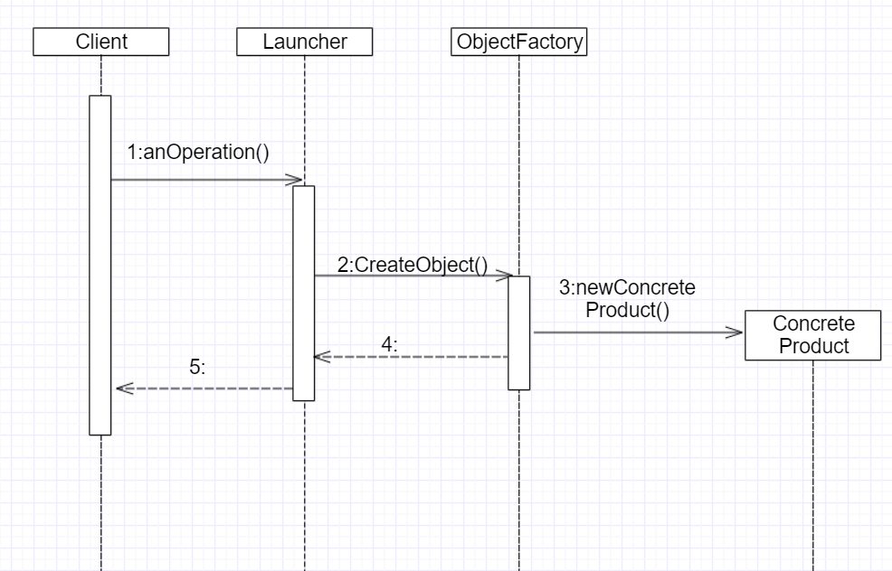

**Sequence diagram: Factory**